Convolutional Neural Network
Create a new Environment
Right click -> Environment
Create Environment. Create the environment in a lower version of Python version 3.9
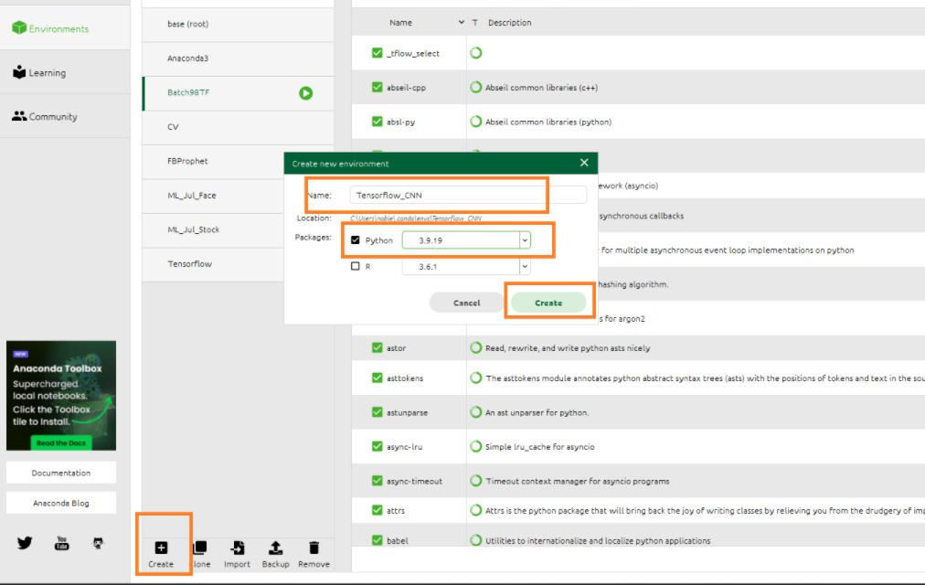

From Not installed Install Numpy

Install tensorflow gpu
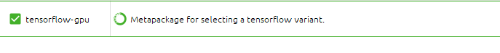
Install keras-gpu

Install a lower version of numpy , if Numpy shows any error
Install by using Jupyter Notebook

pip install numpy==1.23.5

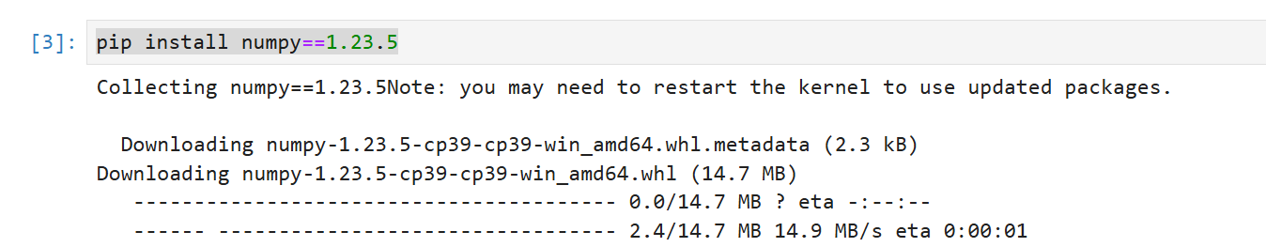

Install Pillow through Jupyter notebook

pip install Pillow

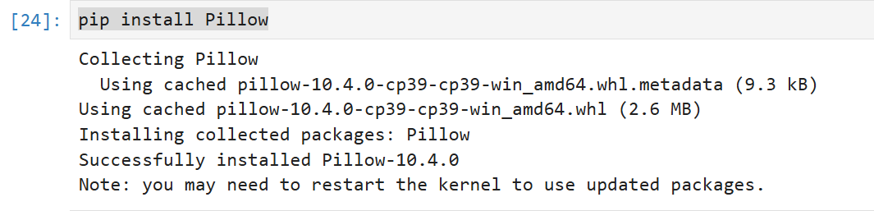

pip install Pillow

Install Tensorflow version

pip install tensorflow==2.18.1

Data Set: Cat/Dog Image
Import Libraries
import tensorflow as tf
import os
import numpy as np

Tensor Flow and Keras Version

print(tf.__version__)
print(tf.keras.__version__)

Pre-processing training test, this is to avoid overfitting. Implement Geomatic transformations like change size, rotate etc
This called image augmentation
Keras Image augmentation details - scroll down and select “Image Data Generator class”
https://keras.io/api/preprocessing/image/

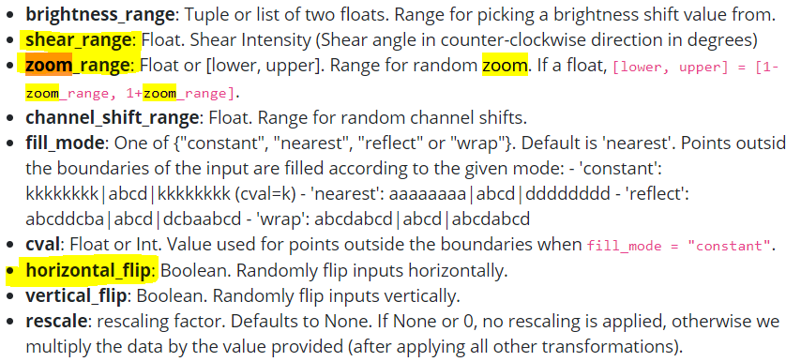

Change Directory
os.chdir ('C:\\Noble\\Training\\Course Content\\Deep Learning\\Training\\Data\\CNN dataset\\')
print (os.getcwd())

Import Image Data Generator

ImageDataGenerator = tf.keras.preprocessing.image.ImageDataGenerator
print (ImageDataGenerator)

Pre-processing training set (Need to get the Model)
Rescale is used to Standardize the image pixel (0 to 255) , Image pixel between (0 and 1 ) divide the pixel by 255
rescale = 1./255 – Divide all pixel by 255 (All pixels between 0 and 1 )

train_datagen = ImageDataGenerator(rescale = 1./255,
shear_range = 0.2,
zoom_range = 0.2,
horizontal_flip = True)

Create model with training data
#class mode is either Binary or Categorical, since here we have two outputs Cat or Dog selected Binary other wise Categirical
target_size- Reduce the Target size to 64 X64
batch_size- Howmany images need to process in one Batch

training_set = train_datagen.flow_from_directory('training_set',
target_size = (64, 64),
batch_size = 32,
class_mode = 'binary')

Pre-processing Test Set
test_datagen = ImageDataGenerator(rescale = 1./255)
test_set = test_datagen.flow_from_directory('test_set',
target_size = (64, 64),
batch_size = 32,
class_mode = 'binary')

Building CNN
Create Sequence
cnn = tf.keras.models.Sequential()

Convolution Layer
Filters : How many filters need to use , here 32 filters ,
kernel_size= 3 is 3 X3 Filters (Dimension of Filter)
input Shape (64, 64, 3] - 64 X 64 – same as target_size in the preprocessing step. 3 for colour Image (three dimension array) for back and white it is 1

cnn.add(tf.keras.layers.Conv2D(filters=32, kernel_size=3, activation='relu', input_shape=[64, 64, 3]))

Pooling
Pool size is size of pool matrix (2 X2)
Slides: how many columns it need to right (slide by two columns)

cnn.add(tf.keras.layers.MaxPool2D(pool_size=2, strides=2))

Add second Convolution Layer

cnn.add(tf.keras.layers.Conv2D(filters=32, kernel_size=3, activation='relu'))
cnn.add(tf.keras.layers.MaxPool2D(pool_size=2, strides=2))

Flattening (This should be the input to KNN)- 1 D vector
cnn.add(tf.keras.layers.Flatten())

Full Connection
Add Layer – fully connected – Activation Function Relu
Unites : Number of hidden neurons

cnn.add(tf.keras.layers.Dense(units=128, activation='relu'))

Output Layer – Activation Function sigmoid
cnn.add(tf.keras.layers.Dense(units=1, activation='sigmoid'))

Training CNN
Compile
cnn.compile(optimizer = 'adam', loss = 'binary_crossentropy', metrics = ['accuracy'])

Training the CNN on the Training set and evaluating it on the Test set

If there are any missing Library error then install Pillow
conda install pillow or - pip install pillow or install from Anaconda Navigator

cnn.fit(x = training_set, validation_data = test_set, epochs = 25)

Predict Future Data -1 Dog

Load the Data set

import numpy as np
import tensorflow.keras.preprocessing.image as image
dog_image = image.load_img('single_prediction/cat_or_dog_1.jpg', target_size = (64, 64))
dog_image

Do the prediction by using the model created

dog_image = image.img_to_array(dog_image)
dog_image = np.expand_dims(dog_image, axis = 0)
dog_result = cnn.predict(dog_image)
training_set.class_indices
if dog_result[0][0] == 1:
prediction = 'dog'
else:
prediction = 'cat'

Print Prediction
print(prediction)

Predict Future Data -2 – Cat
Load Cat image

import numpy as np
import tensorflow.keras.preprocessing.image as image
cat_image = image.load_img('single_prediction/cat_or_dog_2.jpg', target_size = (64, 64))
cat_image

Do the prediction by using the model created

cat_image= image.img_to_array(cat_image)
cat_image = np.expand_dims(cat_image, axis = 0)
cat_result = cnn.predict(cat_image)
training_set.class_indices
if cat_result[0][0] == 1:
prediction = 'dog'
else:
prediction = 'cat'

Print Prediction

print(prediction)

